**An Improved Protocol for Precipitation Measurement**

Karl Roush

Lincroft, NJ 07738 [karlroush@gmail.org](mailto:karlroush@gmail.org)

**Abstract**

This paper provides an alternative protocol for measuring weather precipitation. The proposed protocol uses the following formula: (absolute value of voltage produced/area of a single precipitation element)/duration of weather event. This produces a numeric value with the units of watts, though it is designated as RPU (rain power units) for sake of clarity. This formula takes into account the correlation between variables, such that a short precipitation event with large droplets and high impact force will not produce the same RPU value as a long precipitation event with similar precipitation element characteristics. Voltage, which is directly proportional to impact force, was measured with a mounted piezoelectric component, while an all-purpose baking flour covered tray captured the size of the droplets at the moment of impact. While the RPU value can be calculated for an individual drop, it is better to apply the formula based on the overall average values since it is more useful to look at the weather event as a whole, rather than as individual precipitation elements. Altogether, the low equipment cost and simple formula allow for a greatly improved protocol for precipitation measurement.

**Introduction**

Weather plays a large role in people’s everyday lives. Almost everyone checks the weather before going outside or planning events. However, there are very few ways of measuring and presenting the data. This is most common with precipitation events such as rain or snow.

Currently there are two primary measurements associated with precipitation: accumulation and precipitation element size. The more common of these two measurements is accumulation which is often seen in weather forecasts and reports. The other measurement (precipitation element size) is not as common, but it often used in estimating the amount of damage that a weather event will cause. Climate data measures several other data types, many of which have few practical uses.

As such, there is a dire need for a better protocol to measure precipitation events, beyond the conventional accumulation techniques. This study, which has an end goal of a more descriptive algorithm for weather measurement, has numerous applications in the world. Some of these include more descriptive forecasts (and therefore planning for predicted events) and a better way to describe previous weather events.

**Objective**

This study will determine, and then implement an improved protocol for the purpose of measuring precipitation events.

**Implementation**

A piezoelectric sensor will be used to measure the impact force of rain drops while a flour filled baking sheet will capture the size of the precipitation element upon impact.

Piezoelectric sensor

Flour covered baking sheet

Voltage measurement probe

Wood prop

Angled plate of glass

**Materials and Equipment**

* Piezoelectric sensor (±5.000 volts)
* Voltage measurement probe
* Computer with data collection and analysis software
* Large baking sheet (46 by 33 cm minimum)
* Baking Flour (shifted if possible)
* 12cm x 12cm square piece of flat glass
* Writing implement and paper
* Small piece of wood (5cm thickness)
* Length measurement device (0.001 meter precision)

**Construction**

1. Using a screwdriver, remove the piezoelectric component from the buzzer. Be careful not to bend it.

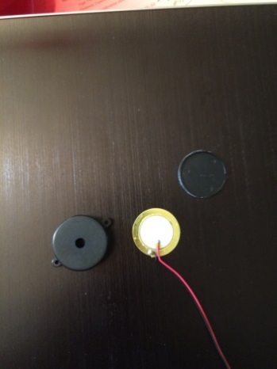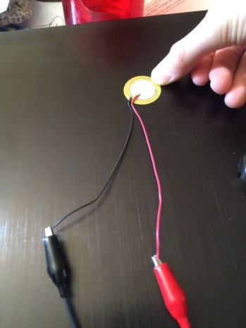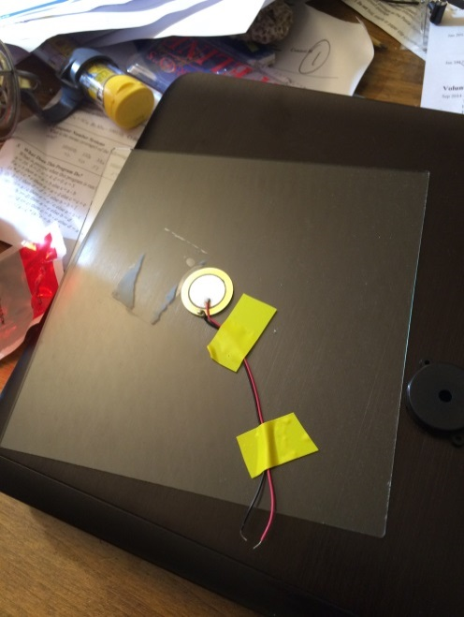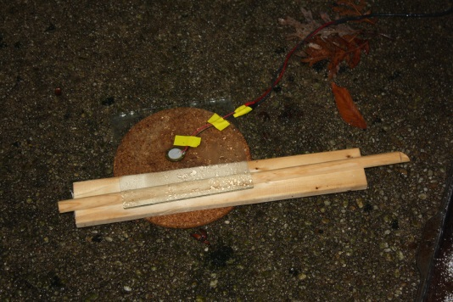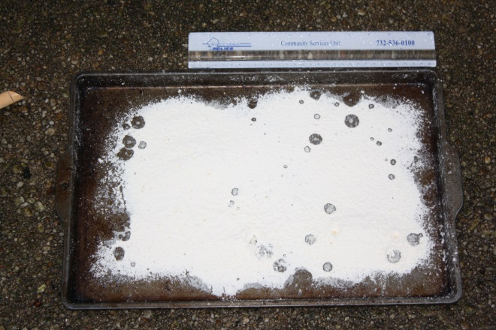

**Disassembled buzzer, piezo electric component is the white/gold piece**

**Data collection in progress (flour tray)**

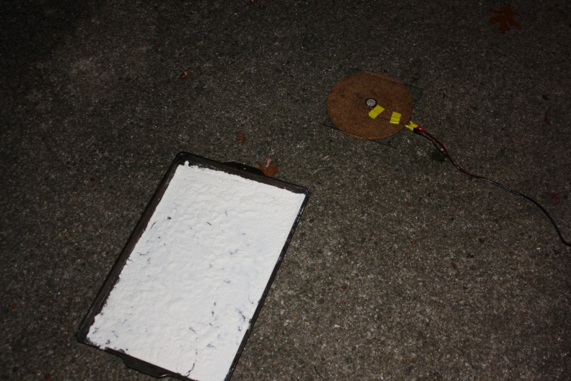

**Voltage probe connected to piezoelectric sensor**

**Sensor and probe attached to glass plate**

**Final sensor setup**

**Overall setup (sensor plate and flour tray)**

1. Attach voltage measurement probe to piezoelectric sensor. The black alligator clip should be connected to the black wire from the sensor and the red clip to the red wire.
2. Using electrical tape, tape the sensor and probe to the piece of glass.
3. Move to the area where data will be collected.
4. Place the piece of wood on the ground.
5. Place the glass with the probe and sensor on the wood so that one end of the glass is propped up by the wood. This is to allow the water to run off.
6. Pour flour into a sifter
7. Sift flour over the baking pan so that a flat surface layer ~2mm is achieved.

**Data Collection**

1. Connect the voltage probe to an interface.
2. Connect the interface to a computer.
3. Open data collection software
4. On day of predicted precipitation event, set the device to record 5 data points per second, starting ~1hr before predicted rainfall.
5. During the rain storm place the baking tray outside for 3 minutes.
6. Take the tray inside and measure the major and minor axes of the impact points

Aja

A

A

A

A

A

A

A

A

A

A

A

A

A

A

Aa

A

A

A

**Data Availability**

The data collection program for recorded five data points per second, totaling 18,000 data points per hour. Likewise, there were several hundred data points collected for the area of the precipitation elements at the moment of impact. Consequently, the large volume of data makes it difficult to present within this paper. As a result, data is available on request.

**Rain Power Unit Formula and Explanation**

The improved protocol for precipitation measurement produces a value with units of watts, designated as rain power units (RPUs) for sake of clarity. The formula for calculating RPU value can be applied to both individual precipitation elements and the entire weather event and is displayed below.

Voltage is directly proportional to impact force due to the usage of a piezoelectric component. As a result, this formula measures the force per unit area in a given time. Simplified even more, the RPU value is a measure of energy per unit time. This value is useful since it not only provides an overall measure of energy, but also takes into account the correlation between the variables of force, area, and time, which can change based on the weather event.

**Sample Data Tables**

Voltage data was recorded in the following format. The data for this example is from the weather event on the thirty-first of December in 2015.

**Sample Data Table 1: Time and Voltage Data (12.31.15)**

|  |  |
| --- | --- |
| **Tine (seconds)** | **Voltage (volts)** |
| 0.0 | 0.008 |
| 0.2 | 0.008 |
|  |  |
| 40339.2 | -0.149 |

The area data was recorded in the format below. The data for this example is also from the weather event on the thirty-first of December in 2015.

**Sample Data Table 2: Area of Precipitation Elements at Moment of Impact (12.31.15)**

|  |  |  |
| --- | --- | --- |
| **Axis 1 (mm)** | **Axis 2 (mm)** | **Area (mm2)** |
| 3 | 1 | 9.4248 |
| 3 | 4 | 37.6991 |
|  |  |  |
| 4 | 3 | 37.6991 |

The voltage data was recorded from the voltage probe at intervals of 0.2 seconds using the program Logger Pro 3.8.6.1 . Data was stored in a .CSV file and manipulated using both Python 3 and Microsoft Excel. The area of the precipitation elements at the moment of impact was measured to the nearest millimeter via a 15 millimeter long measuring stick. The area was calculated using the area of ellipse formula in Microsoft Excel. As stated previously, all data is available on request.

**Graphs**

The collected data was used to produce several graphs. These graphs provide an excellent visual representation of the data and clearly show the pattern and duration of precipitation events. However, the large number of graphs cannot be easily presetned within this paper, so only two were included.

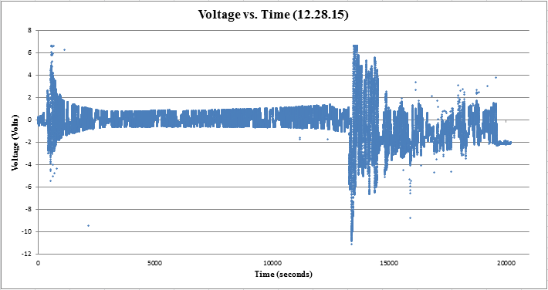

This graph shows the raw voltage data from the weather event on December 28, 2015. From the data, it is clear that there were two separate instances of precipitation. The first was a short, mild event and the second was a longer, slightly more intense event.

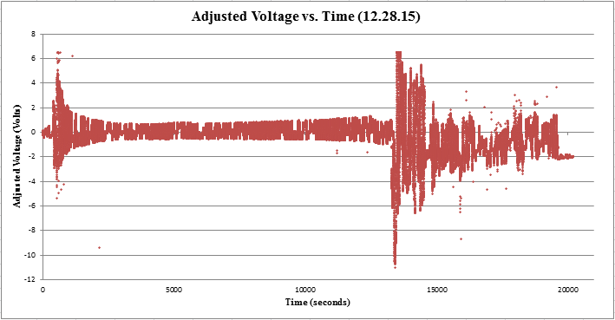

This graph shoes the raw voltage, after it has been adjusted to account for the background voltage fluctuations. However, the background voltage is not completely removed, as evidenced by the lack of a semi-flat line between the two precipitation events. Regardless, the manipulated data is a better representation of the weather event(s).

**Calculations and Data Analysis**

The piezoelectric sensor automatically produces voltage and it repeats in definite cycles. In order to account for this background voltage, the voltage values had to be adjusted. Currently, this is accomplished through an IF/ELSE formula in Excel, as represented below (average voltage is the average voltage of the background fluctuations).

**Snapshot of IF/ELSE Code**

**if** voltage<0:

voltage=voltage+average_voltage

**elif** voltage>0:

voltage=voltage-average_voltage

**else**:

pass

Essentially, this normalizes the data by soothing out the data by either adding or subtracting the average of the background voltage. However, it does neither a complete nor thorough job in removing the background voltage. The ideal way of doing this would be through the application of a sine regression. This is possible through the programing language Python, as demonstrated by the graphic below.

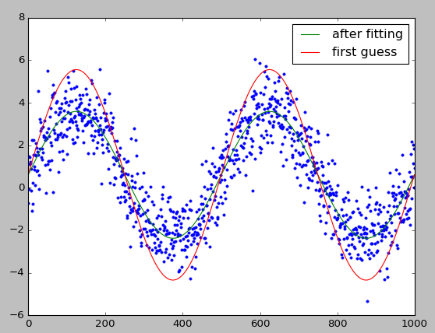

**Graphed Output of Sine Regression Code**

The program determines a line of best fit for the data and then graphs it. However, the program does not produce an equation for this line nor does it currently use the data produced by this project. As such, applying this program to the generated data is something to investigate in future research.

**Summative RPU Data**

Data from the collection period was analyzed to from the following table.

**Table 3: Summative Total Precipitation Data   
(12.23.15-12.31.15)**

|  |  |  |  |
| --- | --- | --- | --- |
| **Precipitation Event** | **Duration (Minutes)** | **Avg. RPU** | **Max RPU** |
| **12.23.15-1** | 60.367 | 0.44611 | 31.58201 |
| **12.23.15-2** | 136.567 | 2.03058 | 83.71443 |
| **12.23.15-3** | 28.917 | 0.14789 | 6.35767 |
| **12.28.15-1** | 43.333 | 0.04244 | 74.59335 |
| **12.28.15-2** | 109.783 | 20.37843 | 222.36286 |
| **12.29.15** | 64.277 | 32.22442 | 119.72495 |
| **12.30.15** | 36.717 | 120.04954 | 358.05810 |
| **12.31.15** | 363.047 | 4.08646 | 798.74593 |

From this table, that data shows that overall RPU values are not directly tied to duration of the precipitation event, as intended by the RPU formula. An interesting data point to note are the 12.31.15 event, which shows that a long event can have a low average RPU value, but a high max RPU value (signifying a heavy rain at some point within the event). Also of note is the 12.30.15 event, which shows that a short and intense event produces very high RPU values.

**Table 4: Summative Precipitation Data per Second (12.23.15-12.31.15)**

|  |  |  |  |
| --- | --- | --- | --- |
| **Precipitation Event** | **Duration (Minutes)** | **Avg. RPU/Sec** | **Max RPU/Sec** |
| **12.23.15-1** | 60.367 | 3.40054E-08 | 2.78248E-06 |
| **12.23.15-2** | 136.567 | 3.02432E-08 | 1.24683E-06 |
| **12.23.15-3** | 28.917 | 4.91276E-08 | 2.11203E-06 |
| **12.28.15-1** | 43.333 | 6.27843E-09 | 1.10345E-05 |
| **12.28.15-2** | 109.783 | 4.69673E-07 | 5.12492E-06 |
| **12.29.15** | 64.277 | 2.16659E-06 | 8.04962E-06 |
| **12.30.15** | 36.717 | 2.47361E-05 | 7.3321E-05 |
| **12.31.15** | 363.047 | 8.61231E-09 | 1.68338E-06 |

This table shows the RPU values per second, essentially the combined RPU value of five data points. Looking at the 12.30.15 event, the data shows that there was a high RPU per second, signifying a large quantity of precipitation elements in one second. The data also shows that within that event, there was a high max RPU per second, meaning that the elements had a high impact force per unit area.

**Conclusions**

The improved protocol for precipitation measurement performed phenomenally. The RPU formula allows for more aspects of the precipitation event to be recorded and it also accounts for the interaction between them. Consequently, this protocol for measurement is far superior to the current size and accumulation methods. However when conducting research on subjects relating to and/or making use of these techniques, the ideal method would be to employ all three. This would allow result in the most complete result possible. In conclusion, this new RPU precipitation protocol is superior to current precipitation methods, though it should be used in conjunction with them.

**Applications**

On the surface, this protocol does not appear to have very many applications. However, due to the unique nature of the RPU formula, this new and alternative precipitation protocol has a myriad of applications.

First and foremost, it can be applied in the weather analysis. Having a better method of precipitation measurement will allow climate scientists to better categorize and analyze weather events. Ergo, the scientists will have a more complete model/record of any events they wish to study.

Another application would be in the field of weather prediction. If meteorologists can provide an RPU estimate for the weather event, people can prepare accordingly since RPU provides information about the weather event’s duration, intensity, and precipitation elements.

Although, as stated earlier, this protocol has numerous other applications, one of the more important ones is in the field of engineering. A RPU value is essentially a measure of the energy of the precipitation element/event, so engineers can adjust their projects according to the required RPU strain. Currently, projects are often based on accumulation values, which are not a reliable measure of stress. With the implementation of this protocol, engineering safety practices could change drastically.

While it may be a simple method for measuring precipitation, the new protocol can be applied in many places. A significant improvement over previous methods, the RPU protocol undeniably has innumerable applications.

**Further Research**

With regards to further research, there are three primary objectives. The first is to incorporate the area measurements and voltage measurements into one device. This would allow for data to be collected for each individual drop thus giving a more accurate RPU value for that drop. The current setup has the area measurement and voltage measurement separate and in future research those processes should be consolidated into one device.

The second objective of further research would be to implement the sine regression program into the data. Currently, the program is able to determine a best fit sine regression for that data and graph it. However, it cannot apply that to the data, nor export the actual equation for the line. In future research, this program should be applied to the data, allowing for faster and more accurate analysis.

The third objective of further research would be to add more variables to the RPU formula. At the time of writing this paper, the formula only takes into account impact force, area, and duration. Precipitation elements have other characteristics that are not accounted for within the formula, and should be in later iterations.

A

A

A

A

A

A

A

A

A

A

A

A

A

A

A

A

A

A

**References and Works Consulted**

Ailsa Allaby and Michael Allaby. "raindrop." A Dictionary of Earth Sciences. 1999. Retrieved March 16, 2016 from Encyclopedia.com: http://www.encyclopedia.com/doc/1O13-raindrop.html Simple definition of a raindrop

Austin, P. M. (1947, August). Measurement of Approximate Raindrop Size by Microwave Attenuation [Scientific Paper]. In AMETSOC Journals. Retrieved January 2, 2016, from http://journals.ametsoc.org/doi/pdf/10.1175/1520-0469(1947)004%3C0121%3AMOARSB%3E2.0.CO%3B2   
Details a method of measuring raindrop size using microwaves

CoCoRaHS - Community Collaborative Rain, Hail & Snow Network. (1998). Retrieved January 2, 2016, from http://www.cocorahs.org/Content.aspx?page=measurerain How to read rain gauges

How to Measure Rain. (n.d.). Retrieved January 2, 2016, from http://www.wikihow.com/Measure-Rain   
Describes a common method of measuring rainfall

Imaoka, K. , Japan Aerospace Exploration Agency. (2014 Feb, 17). Global Precipitation Measurement (GPM): an international mission for measuring global precipitation. The 51st session of the Scientific and Technical Subcommittee of COPUOS [Presentation- Vienna, Austria ]. Retrieved January 2, 2016, from http://www.unoosa.org/pdf/pres/stsc2014/tech-41E.pdf Presentation detailing the relevance of the NASA GPM mission and its objectives.

Kubota, T., Yoshida, N., Urita, S., Iguchi, T., Seto, S., Meneghini, R., . . . Oki, R. (2014, September). Evaluation of Precipitation Estimates by at-Launch Codes of GPM/DPR Algorithms Using Synthetic Data from TRMM/PR Observations (Scientific Paper, Earth Obs. Res. Center, Japan Aerosp. Exploration Agency, 2011). IEEE Journal of Selected Topics in Applied Earth Observations and Remote Sensing, 7(9), 3931-3943. First given at the International Geoscience and Remote Sensing Symposium (IGARSS), 2011 IEEE International

Lemone, P., Dr. (2013). Measuring rainfall – it’s easy and difficult at the same time [Web log post]. Retrieved January 2, 2016, from http://scied.ucar.edu/blog/measuring-rainfall-–-it’s-easy-and-difficult-same-time-0   
UCAR Center for Science Education- details the difficulties of precipitation measurement

Marshall, J., PhD. (2016, February 12). How Is Rainfall Measured? [Web log post]. Retrieved February 18, 2016, from http://www.quickanddirtytips.com/education/math/how-is-rainfall-measured   
Details the various methods of rainfall measurement

McClymont, A. (2013). Raindrop 2013 [Art project that examined the properties (focus on shapes) of rain drops]. Retrieved January 2, 2016, from http://www.alistairmcclymont.com/artwork/raindrop   
Based on an experiment at the University of Manchester in the early 1970s performed by C. P. R Saunders and B. S. Wong.

Measuring the Rain. (2002). Retrieved January 2, 2016, from http://www.infoplease.com/cig/weather/measuring-rain.html   
Describes rainfall/snowfall conversions

NASA’s Real World: Measuring Raindrops. (n.d.). Retrieved January 2, 2016, from https://www.nasa.gov/pdf/462953main_RW6-MeasuringRaindrops_508.pdf   
NASA guide on how to measure raindrops with explanations

National Aeronautics and Space Administration, Global Precipitation Measurement Core Observatory. (n.d.). Dual-frequency Precipitation Radar [Press release]. Retrieved January 2, 2016, from http://pmm.nasa.gov/gpm/flight-project/dpr   
Overview of one of NASA's precipitation measurement devices on their GPM observatory

National Aeronautics and Space Administration, Sharing Earth Observation Resources eoPortal Directory. (n.d.). Https://directory.eoportal.org/web/eoportal/satellite-missions/g/gpm [Press release]. Retrieved January 2, 2016, from https://directory.eoportal.org/web/eoportal/satellite-missions/g/gpm   
Detailed report of NASA's GPM mission including diagrams, specifications and processes

NOAA Satellite Research to Operations Transition Survey for Global Precipitation Measurement (GPM) Mission. (n.d.). Retrieved January 2, 2016, from http://www.nws.noaa.gov/mdl/RITT/lotm/docs/GPM_transition_survey_V1.0.pdf   
Detailed objectives and planned execution of the NASA GPM mission

Pearson, J. E., & Martin, G. E. (1957, November). An Evaluation of Raindrop Sizing and Counting Techniques (Rep.). Retrieved January 2, 2016, from Illinois State Water Survey and University of Illinois website: http://www.isws.illinois.edu/pubdoc/cr/iswscr-10.pdf Discusses various techniques of counting raindrops and their sizes

Rain Gauge. (2006, February 14). Retrieved January 2, 2016, from https://en.wikipedia.org/wiki/Rain_gauge Details what a rain gauge is and how it works

Stott, H. (May 2014). Colliding Raindrops: How Particles Increase Their Size (Project Thesis for degree of Masters of Engineering). University of Bristol. Retrieved January 2, 2016, from http://seis.bris.ac.uk/~hs0849/Raindrops_report.pdf Explanation for how raindrops increase in size, as well as their collisions

The Anatomy of a Raindrop. (n.d.). Retrieved January 2, 2016, from http://pmm.nasa.gov/education/videos/anatomy-raindrop  
Explanation of the parts of raindrops

Tomlinson, C. (2013). A low-cost experiment for determining raindrop size distribution. Retrieved January 2, 2016, from http://www.metlink.org/wp-content/uploads/2013/06/weather_raindropsize.pdf   
Provides a way to measure raindrop size at the moment of impact